# 

**First Stage: Labor**

# 

My Labor & Delivery

Total Women’s Health of Baltimore

# From first contractions to last push, you want to remember every detail of your labor and delivery



Picture of me in labor



**First (Early or Latent) Phase of Labor –** *contractions 5-20 minutes apart: cervix 0-3 cm dilated*

First phase began:

How I felt physically:

How I felt emotionally:

I arrived at the hospital at:

When I arrived, here’s what happened:

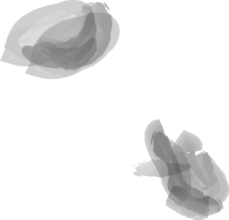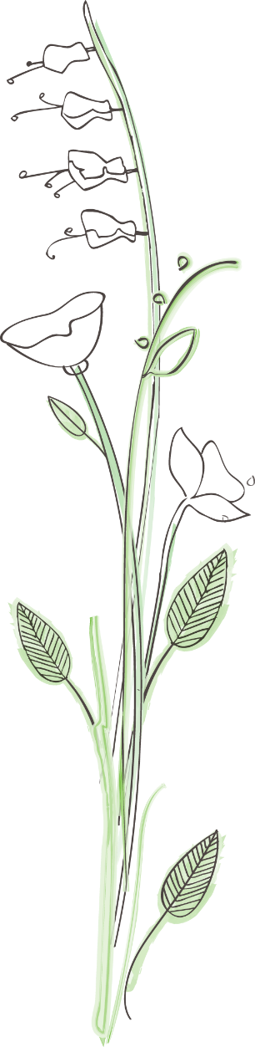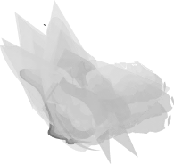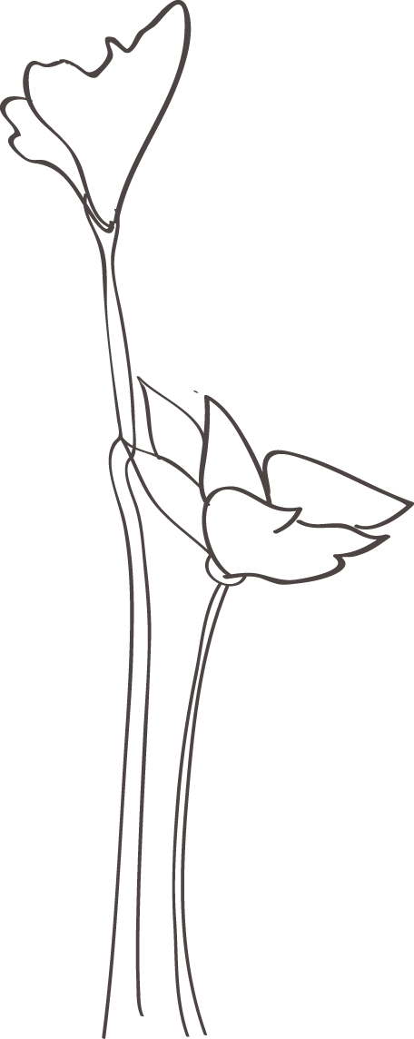

***Notes and Special Thoughts:***



My labor nurse(s):

My room number for labor:

Here’s what my room looked like:

Who was with me:

What I drank:

What I did between contractions:

Medical interventions, if any (IV, fetal monitoring, etc.)

What I did between contractions:

Medical interventions, if any (IV, fetal monitoring, etc.)

**Second (Active) Phase of Labor** *-contractions 3-4 minutes apart: cervix 3-7 cm dilated*

How phase began:

How many hours from beginning of labor?

How I felt physically:

How I felt emotionally:



I managed the pain by:

Who was with me:

My labor nurse(s)

What I did between contractions:

Medical interventions, if any (IV, fetal monitoring, etc.)

**Third (Active or Transitional) Phase of Labor** *-contractions 2-3 minutes apart: cervix 7-10 cm dilated*

Medical interventions, if any (IV, fetal monitoring, etc.)

**Labor Interventions**

The anesthesia or medication I received during labor was:

After receiving the medications, I felt:

My labor was induced by:

How I felt:

My labor was helped along by:



How I felt:

**Second Stage: Delivery**

**Vaginal Delivery**

I began pushing at:

I pushed in these positions:

I pushed for this long:

How I felt physically:

How I felt emotionally:

Pain relief, if any:

Complications, if any:

Who else was at the delivery:



Their reactions:

Who cut the cord:

**Surgical Delivery**

The reason for the C-section:

Who was in the room with me:

How I felt physically:

How I felt emotionally:

What the C-section felt like:

What I was able to see:

It took this long:

Anesthesia used:

How long I was in recovery:

**The Birth**



My Baby is Born!

Baby’s Name:

* Weight:
* Length:
* My baby looks like:
* Where is the birthmark:
* The first thing I noticed about my baby:

Birth Date & Time:

*My Baby*

Memories of the Birth

My baby was born at:

How I felt physically and emotionally

How my partner felt:



Did the baby cry right away:

The hardest part of labor was:

The best part was:

The most unexpected part was:

The nicest thing my partner did for me:

The nicest thing my partner said to me:

The dumbest thing my partner said to me:

How I felt during my labor and delivery:

My message to baby :



Picture of Me and Baby ( and partner if applicable)

Look at my beautiful baby! It was worth it!

I love you baby!

